Skate Park
Part 1 : Work with your lab partner, using the computer, and follow the next simulations:
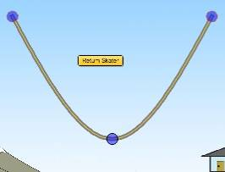
http://phet.colorado.edu/simulations/sims.php?sim=Energy_Skate_Park
A
B
C
D
E
Change the skater and click on “bar graph”
- Where is the kinetic energy maximum?
Where is the maximum kinetic energy?
□ A □ B □ C □ D □ E
- At this point, what can you say about the skater’s speed? It’s …
□ Minimum □ Medium □ Maximum
- Where is the maximum gravitational potential energy? Where is the climax of the gravitational energy?
□ A □ B □ C □ D □ E
- At this point, what can you say about the skater’s height? It’s…
□ Minimum □ Medium □ Maximum
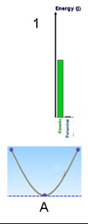
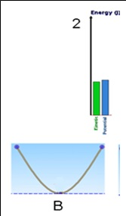
- With bar graphs, draw the skater on the skate park A, B, C.

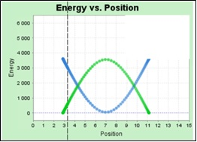

7) Identify the gravitational potential energy graph and color it green.
8) Identify the kinetic energy graph and color it in red.

9) With the graph draw the skate park:
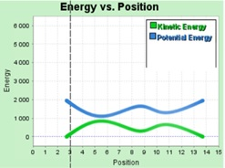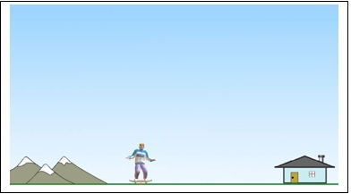

- Change the skater? What is different?
□ Mass □ Speed □ Height □ gravitational potential energy □ kinetic energy □ total energy
- With your answers choose the right words :
- Kinetic energy depends on the □ speed □ height □ mass □ temperature
- Gravitational potential energy depends on the □ speed □ height □ mass □ temperature
- Change” location” and observe. What is different?
□ Mass □ speed □ height □ gravitational potential energy □ kinetic energy □ total energy
- Match the definitions with the words
½ x mass (kg) x [speed (m/s)]²   GPE
m (kg) x g (N/kg) x h ( m )   Total energy
Loss of GPE = gain in KE   KE
- What general statement can you make about the relationship between KE and PE?

Part 2 : Write the principle of the conservation of energy during a fall (5 sentences and use words; kinetic energy (KE), gravitational potential energy (GPE), total energy, increase, decrease.
VOCABULARY :
Gravitional potential energy (GPE)= Energie de position (Ep)
Kinetic energy (KE) = Energie cinétique(Ec)
Mecanic energy = Energie mécanique (Em)
Total energy = Energie totale
Thermic energy = Energie thermique
Energy is measured in Joules (J)
Variable = paramètre

Exercise:
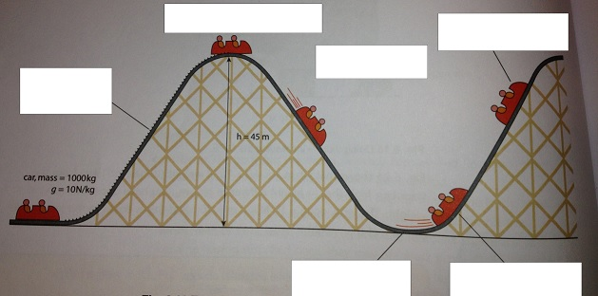
Match these sentences on the diagram
1 ) Slowing down, losing KE and gaining GPE as it gets higher
2 ) The driving force does work on the car, and increases its GPE.
3 ) The car has enough KE to continue up the next slope.
4 ) GPE is transferred to KE and the car speeds up
5 )The highest point - the car has maximum GPE. It is stopped so KE = 0
6 ) Back at the lowest point – maximum KE and GPE = 0
Correction
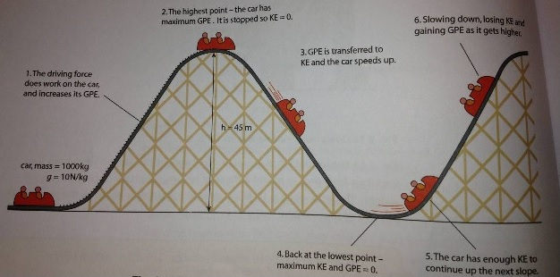

Definitions
A mass that is moving has kinetic energy :
Kinetic energy (J) = ½ x mass (kg) x [speed(m/s)]²
Energy does not have a direction. Speed can be used to calculate the kinetic energy.

Change in gravitational potential energy, GPE (J) = weight (N) x vertical height difference (m)
Or using g = the gravitational field strength (N/Kg)
Change in GPE (J) = m (kg) x g (N/kg) x h (m)

Loss of GPE = gain in KE
The total energy remains the same. This important result is called the principle of conversation of energy. Energy can be stored and transferred in different ways, but when it is all accounted for the total amount stays the same.

